From Fossils to Phylogenies Part 3: How Dinosaurs Fit into the Evolutionary Tree of Life- Teacher Edition
[Written by: Baylee Goodwin, Dane Besser, and Stephen Ramsey]
Vocabulary Words  Phylogenetics  Taxa  Node  Speciation event | Most Recent Common Ancestor (MRCA)  Descendants  Sister Clades  Outgroup

Background
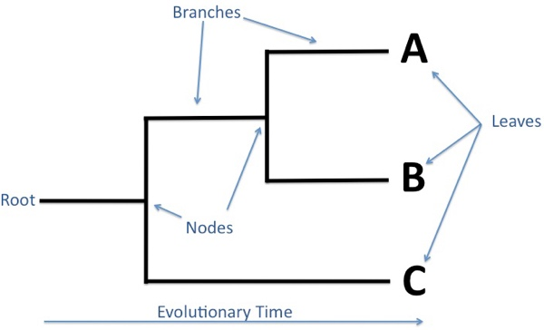
During the Mass Spectrometry and BLAST activities, you were given amino acid sequences that had been recovered from a fossilized bone specimen from a Tyrannosaurus rex (as well as sequences from a Hadrosaur and a Mastodon). You learned how to input the T. rex amino acid sequence into BLAST to identify what present-day animals are most closely related to T. rex. In this activity you will learn how to use a computer to analyze related amino acid sequences from a variety of animals to gain insight on their evolutionary relationships.
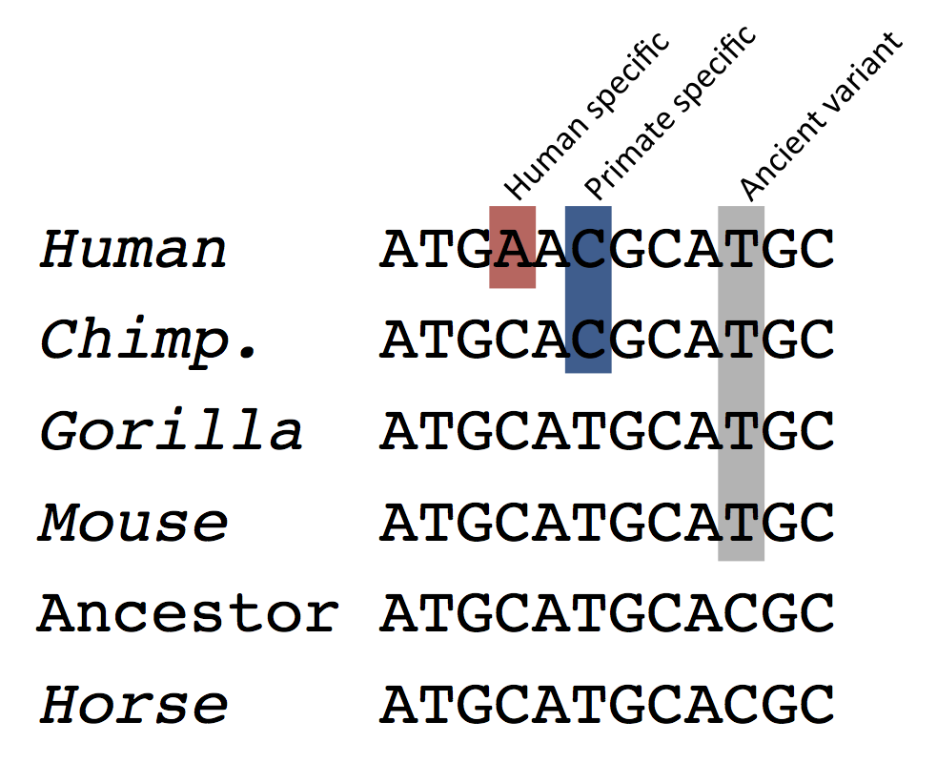
Phylogenetics is the study of evolutionary relationships among a set of taxa, where taxa is another name for groups of organisms, like plants and animals. In phylogenetics, evolutionary relationships are laid out on a phylogenetic tree (fig 1 &3). The root of the tree is the start of the evolutionary lineage being depicted. As you move from the left to the right, you are moving forward in time. As time passes you can see how nodes diverge in two directions, this is a speciation event. Which is when a group of animals separates and evolves into two brand new groups of animal. The nodes also mark where the most recent common ancestor (MRCA) is. For example, in figure 3, A and B are groups of animals that diverged from a MRCA found at the node that join the two. The leaves at the end of the tree mark the descendants of the ancestors. Phylogenetic trees are a useful way to compare how animals are related to one another. In figure 3, animals from group A and B are more closely related to each other than they are to animals in group C. Therefore, A and B would be considered sister clades, since they are the most closely related. Group C would be considered the outgroup since they are the most distantly related.
Figure 1: This is an example of a phylogenetic tree showing how to read it.
Figure 2: This is an example of DNA sequences from multiple species lined up together. Species who share mutations that others do not have are more closely related. This is how molecular biology can help determine evolutionary relationships.

There are two main methods on how to determine the evolution of a set of taxa: morphology vs molecular data. Morphology uses physical features of animals to determine how they evolved, whereas molecular data uses DNA/amino acid sequences to determine where speciation events occurred. Molecular data is typically more accurate since mutations in DNA are the driving force for evolution.
When mutations arise in the DNA sequence of an organism, they can result in changes to the translated amino acid sequence of a protein. For example, the original DNA sequence in a small portion of a gene might have read ATAAGT, but after the mutation it reads ATAACT (i.e., a G was replaced with a C). This changes the amino acid in the sequence from leucine to a stop codon (signaling the end of the protein), which results in the cell making a shortened protein whose function may substantially differ from the original full-length protein. When a mutation is present in an organism's cell, it can be passed on from the organism to its offspring, which is how animals evolve on a molecular scale.
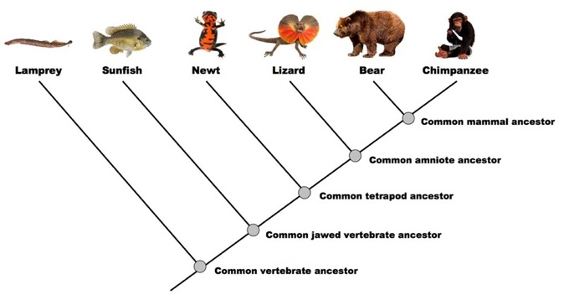
The genetic differences between two species, such as a bird and a lizard, represent the accumulation of billions of mutations over many millions of years. The differences in the DNA (or, as we will study today, protein) sequences among a set of representative species can be used to determine how the species are related. As we will discover, the more closely related organisms will have more similar protein sequences, and the more distantly related organisms will have more dissimilar protein sequences.
Figure 3: This is an example of a basic phylogenetic tree. It highlights where the most recent common ancestors (MRCA) are found on the tree, and which animal groups evolved from the ancestor.
In order to create a phylogenetic tree, the first step is to obtain protein sequence data from a set of animal species that we want to compare. We will be searching for the "alpha-2 type 1 collagen" protein sequence since that is the what scientists were able to extract from the fossilized femur bone of the T. rex. Collagen is evolutionarily rather well-conserved across species, which is why it is a good choice for using amino acid sequences to build a phylogenetic tree. When a protein is “well-conserved” it means that the protein is found in multiple species that are distantly related, collagen is a well-conserved protein found in all animals with true bone. In order to find the collagen sequence, you will conduct a search in an online database called GenBank. The alpha-2 type 1 collagen protein sequences have already been collected for you for most of the animals, however you still need to collect the appropriate amino acid sequence for the T. rex.
The animal species for which you will be building a phylogenetic tree are chicken, rainbow trout, human, dog, cattle, toxodon (Toxodon ‬platensis), mastodon (Mammut americanus), salamander, frog, and T. rex. (Note: these species were selected for this activity because they have alpha-2 type 1 collagen protein sequences available in the database). These animals will allow you to analyze where the T. rex fits in the tree relative to birds, mammals, amphibians, and fish (no reptile data were available), which are four out of the five major vertebrate taxonomic groups. It also allows you to see how other extinct animals like mastodon and toxodon relate to present-day animals.‬‬‬‬‬

Learning Objectives
- Understand how amino acid sequences can be compared using a computer program in order to reconstruct a phylogenetic tree
- Learn how to obtain protein or peptide sequence data in the correct formatting
- Understand how to interpret a phylogenetic tree

Procedure
Obtain T. rex amino acid sequence data:
- Navigate to the following link: http://www.ncbi.nlm.nih.gov
(NCBI stands for the National Center for Biotechnology Information, which is a branch of the National Library of Medicine that hosts the GenBank database). The NCBI website is free for the public to access, and it contains libraries of genomic, genetic, and biomedical data. We will be using it to access protein sequences in GenBank. GenBank contains the sequences of many genes and their protein products, for hundreds of thousands of different species.
- In the search bar at the top of the web page type in “collagen type I alpha 2 T rex“ or “α2t1 collagen T rex” and select the protein database from the drop-down menu, do not include the quotations in the search (The “type I” is a captial I, not the number 1).
- Click on the blue Search button.
- It will provide a list with the top results relevant to your search. It should load 3 to 4 items, be sure to click on the result that says alpha-2(I) chain, not alpha-1(I).
The results display every known protein sequence that matches with the key words alpha 2, type 1, and T. rex. It will show results of things that do not precisely match your search, so be sure to fully read the names of the results. If you were to broaden your search to “alpha 2 collagen” it will result in hundreds of matches, rather than only three or four.
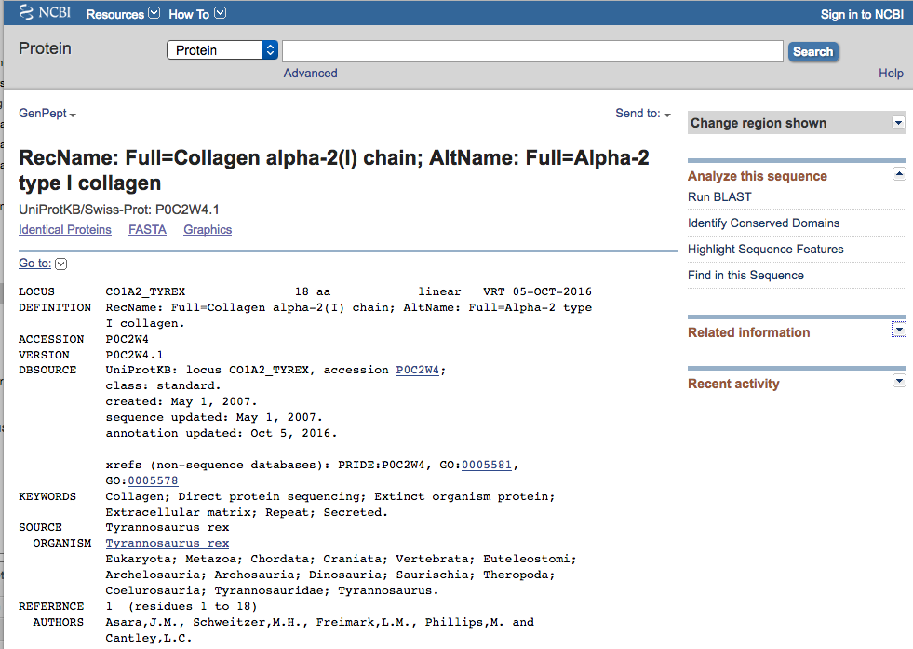
- Once you select the correct result, it will open up this page (pictured below). In order to make sure that you have selected the correct result, look at the column on the left hand side of the page. The fourth item down should say “source organism”, and the organism should be Tyrannosaurus rex. If it does not say it, hit the back button and retype the search query exactly as shown in Step 3.
- Once you reach the correct protein record page, click on the FASTA button underneath the protein’s name in black bold writing.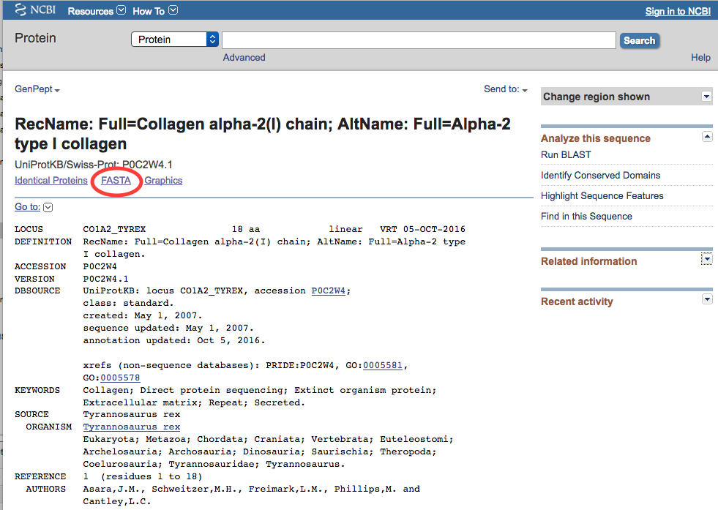

GenBank should then display a FASTA record page, like this:
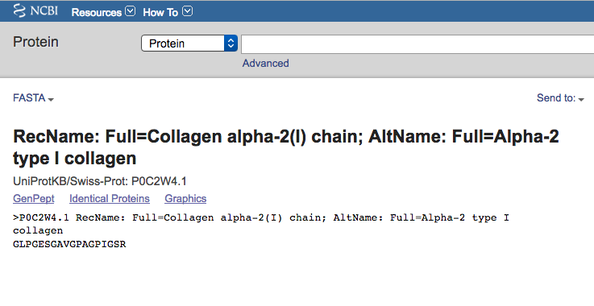
"FASTA" (an abbreviation for "Fast-All") is the simple text-based file format that is often used to transmit DNA or amino acid sequences from one computer program to another. In a FASTA file, the DNA nucleotides or protein amino acids are represented by individual letter codes. The FASTA file format begins with a ">" (greater than) character followed by a description, which is then followed by lines of sequence data.
- On the FASTA record page, select and copy all of the text from the “>” all the way to the end of the amino sequence. 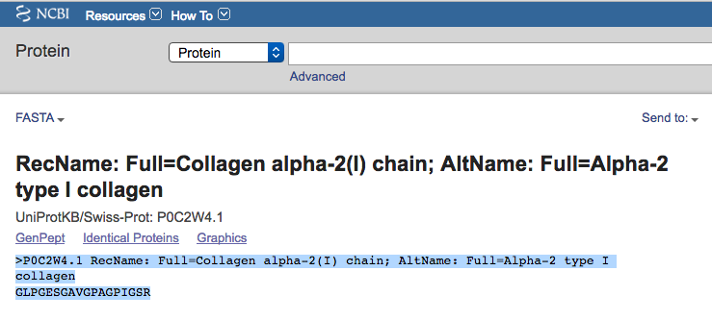
- You are going to paste this sequence into the phylogeny building program in order to include the T. rex in your phylogenetic tree.

Constructing a phylogenetic tree using MAB:
- With your web browser, navigate to the following web page: http://www.phylogeny.fr/alacarte.cgi
This page is the MAB (Methods and Algorithms for Bioinformatics) Phylogeny Analysis tool, which you will use to generate a phylogenetic tree. (Note: most of the MAB website is in French, but the form that you will use to run the Phylogeny Analysis tool is in English.)
- This link will open up directly to “A la carte” mode. Under “Workflow Settings” insert a name for your analysis. 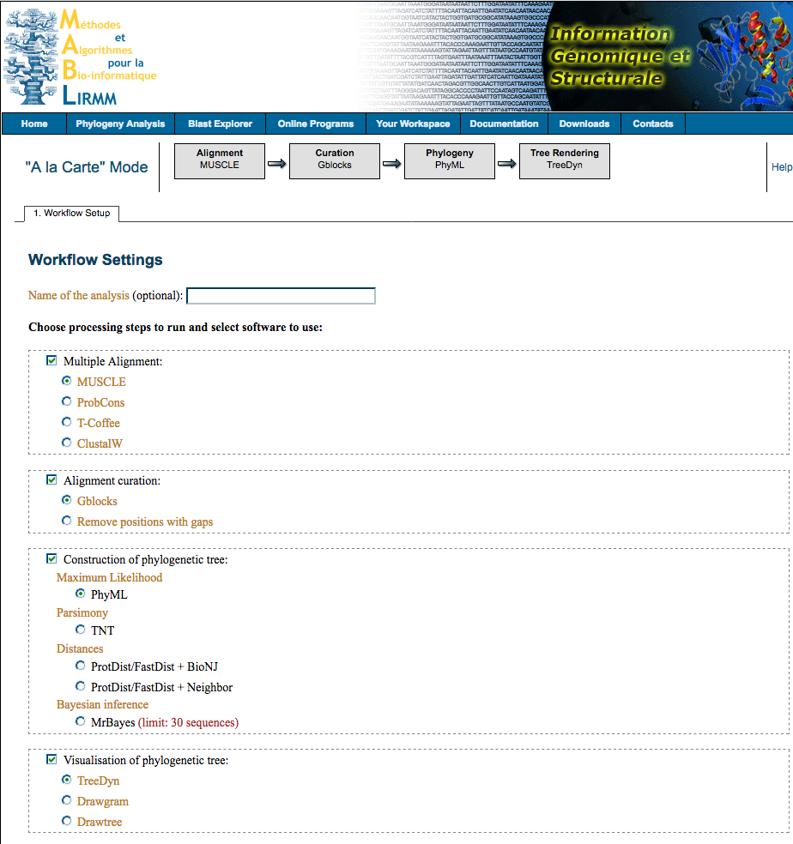
- Scroll to the bottom of the page and select “create workflow”. Do not change any of the settings, they are already set to the correct options for creating your phylogenetic tree.

- MAB should open up to the second browser tab, “data and settings”. This tab gives you the option to upload your file or paste the sequence. Copy and paste the T. rex sequence into the big text box below "Input Data" in the MAB browser window. You need to change the description to say "T-rex". Delete “P0C2W4.1 RecName: Full=Collagen alpha-2(I) chain; AltName: Full=Alpha-2 type I collagen” and replace it with “T-rex”. (Be sure to leave the > otherwise it will not recognize the format. This step is important, now instead of the tree reading the full protein name, it will read the name of the animal.)
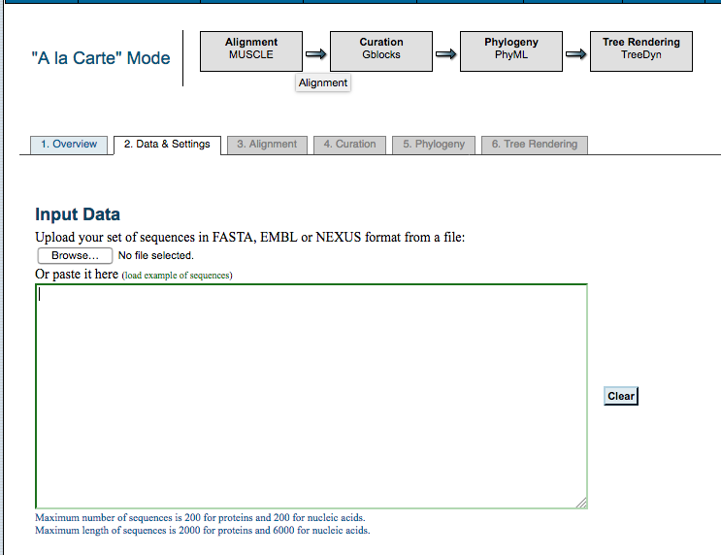
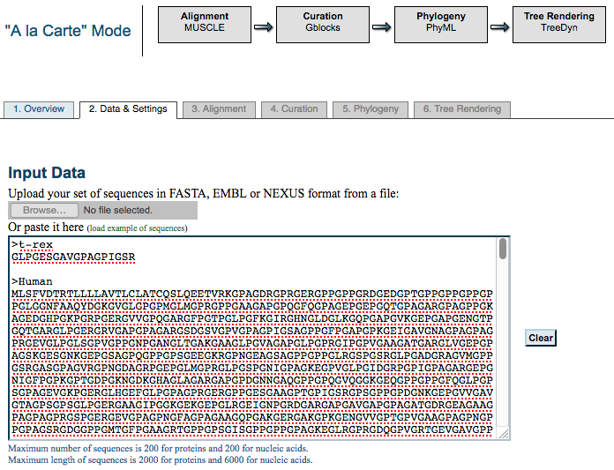
- Now you will need to paste the sequences for all of the other animals being compared in your phylogenetic tree. Scroll down to the end of this PDF and copy everything under the heading “Collagen Sequence Data (Copy and past everything below, including the “>”):”. Paste all of the sequences into the text box below the T. rex sequence.
- Scroll down to the bottom and enter your email address if you wish to be emailed your tree, if not select “submit”. Do not change any settings before hitting submit.
After clicking the Submit button, MAB will display a brief animation of a phylogenetic tree. During this time, MAB is aligning the sequences and then comparing them.
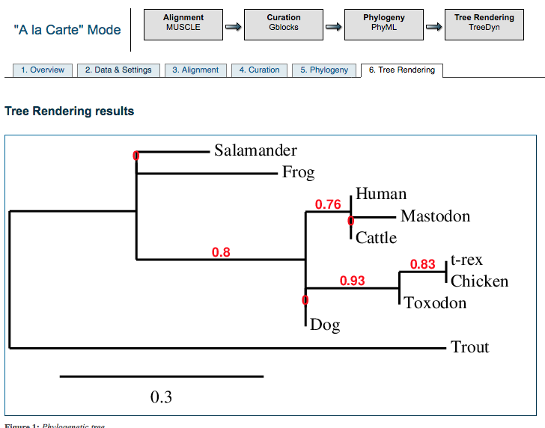
- MAB Phylogeny Analysis can take anywhere between 1 to 5 minutes to construct the phylogenetic tree. Once it loads, it should look like this:

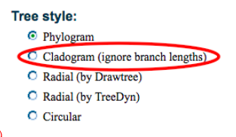
- Scroll down to the “Tree Styles” section toward the bottom of the web page: Click on the radio button for "Cladogram” (in this context, "cladogram" is telling MAB to show a phylogenetic tree without scaling the length of tree branches based on degree of dissimilarity).
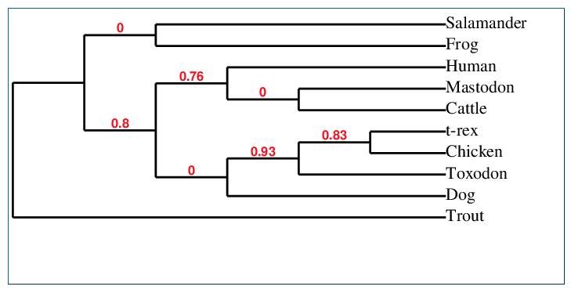
This will make it easier to read and understand the evolutionary relationships. The tree should now look like this:
- The final setting that needs to be adjusted is under “Display”, change the setting from “Branch support values” to “none”.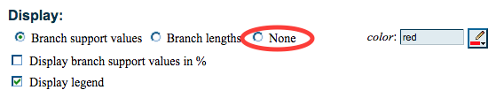
- You now have your finished phylogenetic tree. It should look like this: 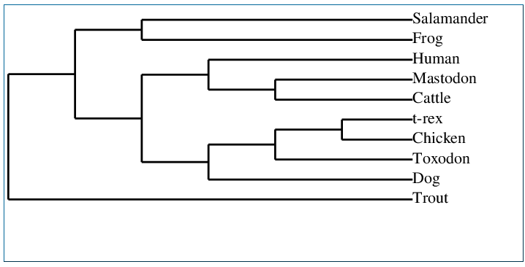
- If you want to save your tree, you can click on the "PNG" or "PDF" links underneath the tree:

Analyzing results
- Which of the species that you analyzed, is the T. rex most closely related to? Does this match with the BLAST results from Session 2?
Chicken (“bird”); this should be the primary match that appeared on BLAST.

- Which pairs of animal species are "sister species"? (i.e., which animals are most closely related?)
T. rex and chicken; Mastodon and cattle; salamander and frog.

- What species is the "out-group" (i.e., the least related to the rest of the species) in this phylogenetic tree?
Trout; this species is least related to the other species.

- Can you find anything puzzling with the relationships depicted in this phylogenetic tree? (hint, look at dog). Do you suppose this might reflect the fact that only a very short amino acid sequence from a single gene was analyzed?
Some things students might find puzzling are: humans evolving before mastodon, even though the mastodon has been extinct for several thousand years; and the fact that chicken evolved from mammals (the dog and toxodon came before the chicken), implying that the birds evolved from mammals. However, birds evolved long before mammals did. This is due to the very short amino acid sequence that was recovered from the T rex; most amino acid sequences are thousands of amino acids long, rather than 18. If a more complete protein was recovered, the tree would be more precise.

Evaluating results
- Why is it important to understand evolutionary relationships among animals?
It is important to understand phylogenetics because it is the study of the classification of life. It explains how evolution of organisms has occurred, and has expanded our knowledge on the animals we share this planet with. The more about other animals we learn, the more we learn about the evolution of humans.

- Why is it important to learn more about extinct animals?
Learning the biology and evolution behind extinct animals can help us learn more about how present day animals evolved. By sequencing the T rex protein, we have scientifically proven that birds evolved from dinosaurs. As we learn more about the past, we can make inferences about how animals are currently evolving.

- Why is it important for scientists to publish their findings, such as genetic sequences, in public databases?
If scientists do not publish their findings, then other scientists would have to go through the process of sequencing an animal’s genome again (which can cost thousands of dollars) in order to get the same results. Sharing data saves money, time, and can help build libraries of genetic data for scientists and the public to use access.

- What other questions could these same techniques be used to answer?
There are a variety of answers students can give here. Here are a few examples that I think are interesting uses of molecular data analysis: using these same methods, unknown animals and insects can be identified, along with its ancestry; when scientists find a new species that has never been described before, they can use bioinformatics to analyze the genome of the animal and identify what it is most closely related to in order to properly name and place it among all other animals; this process also works to identify organisms in the field if an animal/plant specialist is not available.

Collagen Sequence Data (Copy and past everything below, including the “>”):
>Human
MLSFVDTRTLLLLAVTLCLATCQSLQEETVRKGPAGDRGPRGERGPPGPPGRDGEDGPTGPPGPPGPPG
PPGLGGNFAAQYDGKGVGLGPGPMGLMGPRGPPGAAGAPGPQGFQGPAGEPGEPGQTGPAGARGPA
GPPGKAGEDGHPGKPGRPGERGVVGPQGARGFPGTPGLPGFKGIRGHNGLDGLKGQPGAPGVKGEPG
APGENGTPGQTGARGLPGERGRVGAPGPAGARGSDGSVGPVGPAGPIGSAGPPGFPGAPGPKGEIGAV
GNAGPAGPAGPRGEVGLPGLSGPVGPPGNPGANGLTGAKGAAGLPGVAGAPGLPGPRGIPGPVGAAGA
TGARGLVGEPGPAGSKGESGNKGEPGSAGPQGPPGPSGEEGKRGPNGEAGSAGPPGPPGLRGSPGSR
GLPGADGRAGVMGPPGSRGASGPAGVRGPNGDAGRPGEPGLMGPRGLPGSPGNIGPAGKEGPVGLPG
IDGRPGPIGPAGARGEPGNIGFPGPKGPTGDPGKNGDKGHAGLAGARGAPGPDGNNGAQGPPGPQGV
QGGKGEQGPPGPPGFQGLPGPSGPAGEVGKPGERGLHGEFGLPGPAGPRGERGPPGESGAAGPTGPIG
SRGPSGPPGPDGNKGEPGVVGAVGTAGPSGPSGLPGERGAAGIPGGKGEKGEPGLRGEIGNPGRDGA
RGAPGAVGAPGPAGATGDRGEAGAAGPAGPAGPRGSPGERGEVGPAGPNGFAGPAGAAGQPGAKGE
RGAKGPKGENGVVGPTGPVGAAGPAGPNGPPGPAGSRGDGGPPGMTGFPGAAGRTGPPGPSGISGPP
GPPGPAGKEGLRGPRGDQGPVGRTGEVGAVGPPGFAGEKGPSGEAGTAGPPGTPGPQGLLGAPGILGL
PGSRGERGLPGVAGAVGEPGPLGIAGPPGARGPPGAVGSPGVNGAPGEAGRDGNPGNDGPPGRDGQP
GHKGERGYPGNIGPVGAAGAPGPHGPVGPAGKHGNRGETGPSGPVGPAGAVGPRGPSGPQGIRGDKG
EPGEKGPRGLPGLKGHNGLQGLPGIAGHHGDQGAPGSVGPAGPRGPAGPSGPAGKDGRTGHPGTVGP
AGIRGPQGHQGPAGPPGPPGPPGPPGVSGGGYDFGYDGDFYRADQPRSAPSLRPKDYEVDATLKSLNN
QIETLLTPEGSRKNPARTCRDLRLSHPEWSSGYYWIDPNQGCTMDAIKVYCDFSTGETCIRAQPENIPAK
NWYRSSKDKKHVWLGETINAGSQFEYNVEGVTSKEMATQLAFMRLLANYASQNITYHCKNSIAYMDEE
TGNLKKAVILQGSNDVELVAEGNSRFTYTVLVDGCSKKTNEWGKTIIEYKTNKPSRLPFLDIAPLDIGGA
DQEFFVDIGPVCFK
>Chicken
MLSFVDTRILLLLAVTSYLATSQHLFQASAGRKGPRGDKGPQGERGPPGPPGRDGEDGPPGPPGPPGPP
GLGGNFAAQYDPSKAADFGPGPMGLMGPRGPPGASGPPGPPGFQGVPGEPGEPGQTGPQGPRGPPGP
PGKAGEDGHPGKPGRPGERGVAGPQGARGFPGTPGLPGFKGIRGHNGLDGQKGQPGTPGTKGEPGAP
GENGTPGQPGARGLPGERGRIGAPGPAGARGSDGSAGPTGPAGPIGAAGPPGFPGAPGAKGEIGPAGN
VGPTGPAGPRGEIGLPGSSGPVGPPGNPGANGLPGAKGAAGLPGVAGAPGLPGPRGIPGPPGPAGPSG
ARGLVGEPGPAGAKGESGNKGEPGAAGPPGPPGPSGEEGKRGSNGEPGSAGPPGPAGLRGVPGSRGL
PGADGRAGVMGPAGNRGASGPVGAKGPNGDAGRPGEPGLMGPRGLPGQPGSPGPAGKEGPVGFPGA
DGRVGPIGPAGNRGEPGNIGFPGPKGPTGEPGKPGEKGNVGLAGPRGAPGPEGNNGAQGPPGVTGNQ
GAKGETGPAGPPGFQGLPGPSGPAGEAGKPGERGLHGEFGVPGPAGPRGERGLPGESGAVGPAGPIGS
RGPSGPPGPDGNKGEPGNVGPAGAPGPAGPGGIPGERGVAGVPGGKGEKGAPGLRGDTGATGRDGA
RGLPGAIGAPGPAGGAGDRGEGGPAGPAGPAGARGIPGERGEPGPVGPSGFAGPPGAAGQPGAKGER
GPKGPKGETGPTGAIGPIGASGPPGPVGAAGPAGPRGDAGPPGMTGFPGAAGRVGPPGPAGITGPPGP
PGPAGKDGPRGLRGDVGPVGRTGEQGIAGPPGFAGEKGPSGEAGAAGPPGTPGPQGILGAPGILGLPG
SRGERGLPGIAGATGEPGPLGVSGPPGARGPSGPVGSPGPNGAPGEAGRDGNPGNDGPPGRDGAPGF
KGERGAPGNPGPSGALGAPGPHGQVGPSGKPGNRGDPGPVGPVGPAGAFGPRGLAGPQGPRGEKGEP
GDKGHRGLPGLKGHNGLQGLPGLAGQHGDQGPPGNNGPAGPRGPPGPSGPPGKDGRNGLPGPIGPA
GVRGSHGSQGPAGPPGPPGPPGPPGPNGGGYEVGFDAEYYRADQPSLRPKDYEVDATLKTLNNQIETLL
TPEGSKKNPARTCRDLRLSHPEWSSGFYWIDPNQGCTADAIRAYC
DFATGETCIHASLEDIPTKTWYVSKNPKDKKHIWFGETINGGTQFEYNGEGVTTKDMATQLAFMRLLAN
HASQNITYHCKNSIAYMDEETGNLKKAVILQGSNDVELRAEGNSRFTFSVLVDGCSKKNNKWGKTIIEY
RTNKPSRLPILDIAPLDIGGADQEFGLHIGPVCFK

>Trout
MLSFVDNRILLLLAVTSLLASCQSGGLKGPRGAKGPRGDRGPQGPNGRDGKAGLPGIAGPPGPPGLGG
NFAAQFDGGKGSDPGPGPMGLMGSRGPNGPPGAPGPQGFTGHAGEPGEPGQTGSIGARGPTGSAGKP
GEDGNNGRPGKPGDRGGPGTQGARGFPGTPGLPGMKGHRGYNGLDGRKGESGTAGAKGETGAHGA
NGSPGPAGSRGLNGERGRAGPAGPAGARGADGSTGPAGPAGPLGAAGPPGFPGAPGPKGEIGGAGSN
GPSGPQGGRGEPGINGAVGPVGPVGNPGNNGINGAKGAAGLPGVAGAPGFPGPRGGPGPQGPQGST
GARGLGGDPGPSGQKGDSGAKGEPGHSGVQGAAGPAGEEGKRGSTGEVGATGPAGLRGARGGAGTR
GLPGLEGRGGPIGMPGARGATGPGGIRGAPGDAGRAGESGLTGARGLPGNSGQGGPPGKEGPPGAAG
LDGRTGPPGPTGPRGQPGNIGFPGPKGPGGEAGKGGDKGPTGATGLRGGPGADGNNGAPGPAGVVG
NTGEKGEQGPAGAPGFQGLPGPAGPAGEAGKAGNQGMPGDQGLPGPAGVKGERGNSGPAGSAGSQG
AIGARGPAGTPGPDGGKGEPGSVGIVGAAGHQGPGGMPGERGAGGTPGPKGEKGEGGHRGLEGNMG
RDGARGGPGPSGPPGPSGANGEKGESGSFGPAGPAGLRGPSGERGEGGPAGLPGFAGPPGSDGQSGP
RGEKGPAGGKGDVGPAGPAGPSGQSGPSGASGPAGPPGGRGDAGPSGLTGFPGAAGRVGGPGPAGI
AGPPGSAGPAGKDGPRGLRGDPGPGGPQGEQGVVGPAGISGDKGPSGESGPPGAPGTAGPQGVLGPS
GFVGLPGSRGDKGLPGGPGAVGEPGRLGPAGASGPRGPAGNIGMPGMTGTQGEAGREGNSGNDGPP
GRPGAAGFKGDRGEPGSPGALGSSGQPGPNGPAGSAGRPGNRGESGPTGNGGPVGAVGARGAPGPA
GPRGEKGGAGEKGDRGMKGLRGHGGLQGMPGPNGPSGETGSAGITGPAGPRGPAGPHGPPGKDGRA
GGHGAIGPVGHRGSPGHLGPAGPPGSPGLPGPAGPAGGGYDQSGGYDEYRADQPSFRAKDYEVDATI
KSLNSQIENLLTPEGSKKNPARTCRDIRLSHPDWSSGFYWIDPNQGCIADAIKAYCDFSTGHTCIHPHPE
SIARKNWYRSSENKKHVWFGETINGGTEFAYNDETLSPQSMATQLAFMRLLANQATQNITYHCKNSVA
YMDGENGNLKKAVLLQGSNDVELRAEGNSRFTFNVLEDGCTRHTGQWSKTVIEYRTNKPSRLPILDIAP
LDIGEADQEFGLDIGPVCFK
>Dog
MLSFVDTRTLLLLAVTSCLATCQSLQEATARKGPTGDRGPRGERGPPGPPGRDGDDGIPGPPGPPGPPG
PPGLGGNFAAQYDGKGVGLGPGPMGLMGPRGPPGASGAPGPQGFQGPAGEPGEPGQTGPAGARGPPG
PPGKAGEDGHPGKPGRPGERGVVGPQGARGFPGTPGLPGFKGIRGHNGLDGLKGQPGAPGVKGEPGA
PGENGTPGQTGARGLPGERGRVGAPGPAGARGSDGSVGPVGPAGPIGSAGPPGFPGAPGPKGEIGPVG
NPGPAGPAGPRGEVGLPGVSGPVGPPGNPGANGLTGAKGAAGLPGVAGAPGLPGPRGIPGPVGAAGAT
GARGIVGEPGPAGSKGESGNKGEPGSAGAQGPPGPSGEEGKRGPNGEAGSAGPSGPPGLRGSPGSRG
LPGADGPAGVMGPPGPRGATGPAGVRGPNGDSGRPGEPGLMGPRGFPGAPGNVGPAGKEGPMGLPGI
DGRPGPIGPAGARGEPGNIGFPGPKGPTGDPGKNGDKGHAGLAGARGAPGPDGNNGAQGPPGPQGV
QGGKGEQGPAGPPGFQGLPGPAGTAGEVGKPGERGLPGEFGLPGPAGPRGERGPPGESGAAGPSGPIG
SRGPSGPPGPDGNKGEPGVLGAPGTAGASGPGGLPGERGAAGIPGGKGEKGETGLRGEIGNPGRDGA
RGAPGAMGAPGPAGATGDRGEAGPAGPAGPAGPRGTPGERGEVGPAGPNGFAGPAGAAGQPGAKGE
RGTKGPKGENGPVGPTGPIGSAGPSGPNGPPGPAGSRGDGGPPGATGFPGAAGRTGPPGPSGITGPPG
PPGAAGKEGLRGPRGDQGPVGRTGETGASGPPGFTGEKGPSGEPGTAGPPGTPGPQGLLGAPGILGLP
GSRGERGLPGVAGSVGEPGPLGIAGPPGARGPPGAVGAPGVNGAPGEAGRDGNPGNDGPPGRDGQA
GHKGERGYPGNIGPVGAVGAPGPHGPVGPTGKHGNRGEPGPAGSVGPVGAVGPRGPSGPQGIRGDKG
EPGEKGPRGLPGLKGHNGLQGLPGLAGQHGDQGAPGSVGPAGPRGPAGPSGPAGKDGRTGQPGTVG
PAGIRGSQGSQGPAGPPGPPGPPGPPGPSGGGYDFGYEGDFYRADQPRSPPSLRPKDYEVDATLKSLN
NQIETLLTPEGSRKNPARTCRDLRLSHPEWSSGYYWIDPNQGCTMDAIKVYCDFSTGETCIRAQPENIP
AKNWYRNSKVKKHIWLGETINGGTQFEYNVEGVTTKEMATQLAFMRLLANHASQNITYHCKNSIAYMD
EETGNLKKAVILQGSNDVELVAEGNSRFTYTVLVDGCSKKTNEWRKTIIEYKTNKPSRLPILDIAPLDIGD
ADQEFRVDVGPVCFK

>Cattle
MLSFVDTRTLLLLAVTSCLATCQSLQEATARKGPSGDRGPRGERGPPGPPGRDGDDGIPGPPGPPGPPG
PPGLGGNFAAQFDAKGGGPGPMGLMGPRGPPGASGAPGPQGFQGPPGEPGEPGQTGPAGARGPPGPP
GKAGEDGHPGKPGRPGERGVVGPQGARGFPGTPGLPGFKGIRGHNGLDGLKGQPGAPGVKGEPGAPG
ENGTPGQTGARGLPGERGRVGAPGPAGARGSDGSVGPVGPAGPIGSAGPPGFPGAPGPKGELGPVGN
PGPAGPAGPRGEVGLPGLSGPVGPPGNPGANGLPGAKGAAGLPGVAGAPGLPGPRGIPGPVGAAGATG
ARGLVGEPGPAGSKGESGNKGEPGAVGQPGPPGPSGEEGKRGSTGEIGPAGPPGPPGLRGNPGSRGLP
GADGRAGVMGPAGSRGATGPAGVRGPNGDSGRPGEPGLMGPRGFPGSPGNIGPAGKEGPVGLPGIDG
RPGPIGPAGARGEPGNIGFPGPKGPSGDPGKAGEKGHAGLAGARGAPGPDGNNGAQGPPGLQGVQGG
KGEQGPAGPPGFQGLPGPAGTAGEAGKPGERGIPGEFGLPGPAGARGERGPPGESGAAGPTGPIGSRG
PSGPPGPDGNKGEPGVVGAPGTAGPSGPSGLPGERGAAGIPGGKGEKGETGLRGDIGSPGRDGARGA
PGAIGAPGPAGANGDRGEAGPAGPAGPAGPRGSPGERGEVGPAGPNGFAGPAGAAGQPGAKGERGTK
GPKGENGPVGPTGPVGAAGPSGPNGPPGPAGSRGDGGPPGATGFPGAAGRTGPPGPSGISGPPGPPGP
AGKEGLRGPRGDQGPVGRSGETGASGPPGFVGEKGPSGEPGTAGPPGTPGPQGLLGAPGFLGLPGSRG
ERGLPGVAGSVGEPGPLGIAGPPGARGPPGNVGNPGVNGAPGEAGRDGNPGNDGPPGRDGQPGHKG
ERGYPGNAGPVGAAGAPGPQGPVGPVGKHGNRGEPGPAGAVGPAGAVGPRGPSGPQGIRGDKGEPG
DKGPRGLPGLKGHNGLQGLPGLAGHHGDQGAPGAVGPAGPRGPAGPSGPAGKDGRIGQPGAVGPAGI
RGSQGSQGPAGPPGPPGPPGPPGPSGGGYEFGFDGDFYRADQPRSPTSLRPKDYEVDATLKSLNNQIE
TLLTPEGSRKNPARTCRDLRLSHPEWSSGYYWIDPNQGCTMDAIKVYCDFSTGETCIRAQPEDIPVKNW
YRNSKAKKHVWVGETINGGTQFEYNVEGVTTKEMATQLAFMRLLANHASQNITYHCKNSIAYMDEETG
NLKKAVILQGSNDVELVAEGNSRFTYTVLVDGCSKKTNEWQKTIIEYKTNKPSRLPILDIAPLDIGGADQ
EIRLNIGPVCFK
>Frog
MLSFVDLRSVLLLAVTLYLVTCQEVRRGPRGDKGPPGEQGPPGIPGRDGEDGLPGLPGPPGVPGLGGNF
AAQYDPSKSAEPGQQGIMGPRGPPGPPGSPGSQGFQGLPGENGEPGQTGPVGSRGPSGAPGKAGEDG
HPGKSGRPGERGPVGPQGARGFPGTPGLPGFKGIRGHTGSDGQKGAPGAAGVKGENGANGDNGSPG
QAGARGLPGERGRIGPAGSAGSRGSDGSSGPVGPAGPIGSAGAPGLPGAPGAKGELGPAGNNGPTGA
AGGRGEPGPPGSLGPAGPPGNPGTNGVNGAKGTAGLPGVGGAPGLPGGRGIPGPAGPAGPSGARGLA
GDPGIAGGKGDTGSKGEPGSVGQQGPAGPSGEEGKRGPNGEAGSSGPSGNAGIRGVPGTRGLPGPD
GRAGGIGPAGSRGSSGPPGARGPNGDAGRPGEPGLLGARGLPGFSGSNGPQGKEGPAGPQGIEGRSG
AAGPAGARGEPGAIGFPGPKGPNGEPGKNGDKGNQGPSGNRGAPGPDGNNGAQGPAGLGGATGEKG
EQGPSGAPGFQGLPGPGGPPGEVGKPGERGAPGDFGPPGSAGTRGERGAPGESGGAGPHGPSGSRGP
SGAPGPDGQKGEPGAAGLNGGLGPSGPAGIPGERGTAGTPGTKGEKGDAGNSGDYGNPGRDGARGP
AGAAGAPGPAGGPGDRGESGPAGPSGVAGPRGAPGERGEAGPAGPTGFAGPPGAAGHTGAKGDRGA
KGPKGEAGSPGPLGAHGSAGPAGPNGPAGSTGARGDAGPSGATGFPGPAGRAGAPGPPGNVGPSGPT
GHPGKDGSRGPRGDSGPVGRPGEQGQHGPVGLAGDKGPSGEAGPAGPPGAAGPSGVLGARGILGLP
GTRGERGLPGGPGSNGEPGPSGLAGSSGPRGPPGSVGSPGPVGHSGEAGRDGHPGNDGPPGRDGLP
GAKGERGYPGNTGPSGLAGAPGPAGSAGPAGKSGNRGEGGPSGPAGITGPSGPRGPAGPQGVRGDKG
EAGERGARGLDGRKGHNGLSGLPGPSGTPGETGPSGSVGPVGPRGPSGPSGPPGKEGRSGHPGAMGP
VGPRGPAGFTGPAGPPGPPGPPGHAGPSGGGYDGGDGGEYYRADQPERKPKDYEVDATLKSLNQQIEV
ILTPEGSRKNPARTCRDLRLSHPEWTSGFYWIDPNQGCTSDAIRVFCDFSSGETCIHANPDEITQKNWY
INTSNKDKKHLWFGEILNGGTQFEYHDEGLTAKDMATQLAFMRLLANQASQNITYHCKNSIAYMDEET
GNLKKAVILQGSNDVELRAEGNTRFTYSVLEDGCTKHTGEWGKTVIEYRTNKPSRLPI
LDIAPLDIGGHDQEIGFEIGPVCFK

>Toxodon
GPMGIMGPRGPPGASGAPGPAGEPGEPGQTGPAGARGPPGPPGKAGEDGHPGKPGRPGERGVVGPQG
ARGFPGTPGIPGFKGIRGHNGIDGIKGQPGAPGVKGEPGAPGENGTPGQAGARGIPGERGRVGAPGPA
GARGSDGSVGPVGPAGPIGSAGPPGFPGAPGPKGEIGPVGNPGPAGPAGPRGEVGIPGVSGPVGPPGN
PGANGITGAKGAAGIPGVAGAPGIPGPRGIPGPVGAAGATGARGIVGEPGPAGSKGESGNKGEPGSAG
PQGPPGPAGEEGKRGPNGEAGSTGPTGPPGIRGSRGIPGADGGSRGATGPAGVRGDSGRPGEPGIMG
PRGFPGSPGNIGPAGKEGPVGIPGIDGRPGPTGPAGARGEPGNIGFPGPKGPTGDPGKNGDKGHAGIA
GARGPAGPPGFQGIPGPAGTAGEVGKPGERGIPGEFGIPGPAGARGERGPPGESGAVGPAGPIGSRGPS
GPPGPDGNKGEPGNIGAIGTAGPSGPSGIPGERGAAGIPGGKGEKGETGIRRGAPGAIGAPGPAGANG
DRGEAGPAGPAGPAGPRGSPGERGEVGPAGPNGFAGPAGAAGQPGAKGERGTKGPKGENGPVGPTGP
VGAAGPAGPNGPPGPAGSRGDGGPPGATGFPGAAGRTGPPGPAGITGPPGPPGAAGKEGIRGPRGDQ
GPVGRSGETGASGIPGFAGEKGPAGEPGTAGIPGTPGPQGIIGAPGIIGIPGSRGERGIPGVAGSIGEPG
PIGIAGPPGARGPPGAVGNPGVNGAPGEAGRHGNRGEPGPAGSVGPAGAVGPRGPSGPQGIRGDKGE
PGDKGPRGIPGIKGHNGIQGIPGIAGQHGDQGAPGAVGPAGPRGPAGPSGPAGKDGRIGHPGTVGPA
GIRGSQGSQGPAGPPGPPGPPGPPGPS
>Mastodon
QYDAKGVGLGPGPMGLMGPRGPPGATGPPGSPGFQGPPGEPGEPGQTGPAGSRGPAGPPGKAGEDGH
PGKPGRPGERGVVGPQGARGFPGTPGLPGFKGIRGHNGLDGLKGQPGAPGVKGEPGAPGENGTPGQI
GARGLPGERGRVGGPGPAGARGSDGSVGPVGPAGPIGSAGPPGFPGAPGPKGEIGPVGNPGPSGPAGP
RGEAGLPGVSGPVGPPGNPGANGLAGAKGAAGLPGVAGAPGLPGPRGIPGPVGAAGATGARGIVGEPG
PAGSKGESGSKGEPGSAGPQGPPGPSGEEGKRGPNGEAGSAGPAGPPGLRGGPGSRGLPGADGRAGV
MGPPGSRGASGPAGVRGPSGDSGRPGEPGVMGPRGLPGSPGNVGPAGKEGPAGLPGIDGRPGPIGPA
GARGEPGNIGFPGPKGPAGDPGKNGDKGHAGLAGPRGAPGPDGNNGAQGPPGLQGVQGGKGEQGPA
GPPGFQGLPGPSGTAGEAGKPGERGIPGEFGLPGPAGPRGERGPPGQSGAAGPTGPIGSRGPSGPPGP
DGNKGEPGVVGAPGTAGPSGPVGLPGERGAAGIPGGKGEKGETGLRGDTGNTGRDGARGAPGAVGAP
GPAGATGDRGEAGPAGSAGPAGPRGSPGERGEVGPAGPNGFAGPAGAAGQAGAKGERGTKGPKGEN
GPVGPTGPVGAAGPAGPNGPPGPAGSRGDGGPPGATGFPGAAGRTGPPGPAGITGPPGPPGAAGKEGL
RGPRGDQGPVGRTGETGASGPPGFAGEKGSSGEPGTAGPPGAPGPQGILGPPGILGLPGSRGERGLPG
VAGAVGEPGPLGIAGPPGARGPPGAVGSPGVNGAPGEAGRDGNPGSDGPPGRDGLPGHKGERGYPGN
AGPVGTAGAPGPQGPLGPAGKHGNRGEPGPAGSVGPVGAVGPRGPSGPQGARGDKGEAGDKGPRGL
PGFKGHNGLQGLPGLAGQHGDQGSPGSVGPAGPRGPAGPSGPVGKDGRPGHAGAVGPAGVRGSQGS
QGPSGPPGPPGPPGPPGPSGGGYDFGYDGDFYRA
>Salamander
MLSFVDTRIVLLLAVTSSLATCQYNYEANRGPRGYKGPQGDQGPPGAPGRDGVDGPPGPAGPPGPPGP
SGLGGNFAAQYDGGKSDPGPGPMGMMGPRGPPGPSGSPGAQGFQGLPGEPGEPGQTGPVGSRGPTG
PPGKSGEDGSPGKSGRPGERGTVGTQGARGFPGTPGLPGFKGLRGHNGFDGVKGAAGSQGAKGETG
ANGENGSPGQAGARGLPGERGRVGGAGPGARGSDGSAGPSGPAGPIGSAGAPGLPGAPGAKGEIGSA
GNNGPSGPAGSRGDPGLPGSVGPVGPAGNPGSNGVSGAKGAAGLPGVGGAPGLPGPRGIPGPQGASG
AAGARGLAGDPGSPGGKGDSGSKGEPGSAGQQGNAGPSGEEGKRGPNGEPGSSGPAGPAGIRGVPG
TRGLPGPDGRAGGMGPPGSRGSSGPAGVRGPSGDAGRPGEPGLLGQRGLPGFPGNTGPVGKEGPAGP
AGIEGRTGAAGPTGARGEPGSIGFPGPKGPGGEPGKNGDKGSAGPSGARGAPGPDGNNGAQGPPGVV
GNTGEKGEQGPAGAPGFQGLPGPGGAAGEAGKVGDRGMPGDFGPPGPAGVRGERGAPGESGSAGPL
GPVGSRGPSGPPGPDGTKGEPGVAGLAGAVGPSGSGGSPGERGGAGTPGPKGEKGEAGNRGEYGNQ
GRDGARGPAGASGAPGPSGGPGDRGESGPSGPAGPAGSRGAPGERGEHGPGGPTGFGGPPGAAGHT
GVKGERGEKGPKGELGPQGPVGASGASGPAGPNGPAGAPGSRGEVGPAGATGFPGPAGRTGGPGPAG
MGGPPGPSGHAGKDGPRGPRGDSGPVGRPGEQGGLGPQGISGEKGPSGEPGTAGPPGSSGPSGVLG

ARGILGLPGTRGERGLPGGPGGNGEPGATGPTGTAGSRGAPGPVGSAGMNGPAGEAGRDGNPGNDGP
PGRDGQAGAKGERGYPGNTGGVGHAGAPGPHGSVGPAGKSGNRGEPGPSGSQGPAGLPGARGPAGP
AGSRGDKGESGEKGGRGLDGRKGHNGLQGLPGLPGTSGEAGSAGPSGPSGPRGPAGPSGPPGKDGH
SGQPGPVGPAGVRGSPGHQGPAGPPGSPGAPGPAGPSGGGYDGGFEGGEFYRADQPSLRPKDYEVDS
TLKTLNNQIETLLTPEGSRKNPARTCRDLRLSHPEWSSGFYWIDPNQGCTADAIRVYCDFSTGETCIHSN
PETISAKTSYVNKNPKDKKHVWVGEVLNGGTQFEYNEEGVTTKDMATQFAFMRLLANHASQNITYHCK
NSIAYMDGETGNLKKAVLLQGSNDVELRAEGNSRFTFSVLEDSCTKHTGEWGRTVMEYRTNKPSRLPIL
DIAPMDIGGAEQEFRVDIGPVCFK

This program uses a common method for aligning the sequences, called MUSCLE (Multiple Sequence Comparison by Log-Expectation). This step is important because it uses an algorithm to align each peptide sequence in order to accurately predict where mutations occurred that signal how the animals evolved. If the sequences are not aligned they can not be used to generate a phylogenetic tree.

