Case Study: should dinosaurs be “cloned” from ancient dna?

What are the ethical considerations for and against the cloning of dinosaurs into today’s world?
[Adapted by Dane Besser, Baylee Goodwin, and Stephen A. Ramsey from an activity written by Constance M. Soja and Deborah Huerta]
Background
NOTE: This activity describes a hypothetical scenario in which the technology has been developed that will enable the cloning of dinosaurs from ancient DNA samples. In the process of introducing the fictional scenario for the activity, some relevant non-fiction background material will be provided in round text boxes.
You've been asked to participate in a Presidential blue-ribbon commission that will consider whether dinosaurs should be cloned from ancient DNA and brought back to life. Your commission will make a recommendation for or against dinosaur cloning that will be considered, and then ultimately decided on, by a panel of High Court judges in a court proceeding. The commission's team includes experts with various backgrounds and interests, to ensure that diverse points-of-view are considered in the decision-making process. The question of whether dinosaurs should be reintroduced is particularly urgent because scientists at multiple sites around the world are currently refining the laboratory techniques that make dinosaur cloning possible.
Dinosaurs were the dominant form of animal life on land for more than 100 million years. Dinosaurs lived on all continents in a wide variety of environments from the poles to the tropics. Many scientists believe that during the Mesozoic era (which began 252 million years ago) mammals were unable to dominate life on land due to the presence of dinosaurs. Only during the breakup of Pangea and after dinosaurs became extinct, did mammals undergo an evolutionary variation and growth to occupy many of the ecological roles left vacant as a result of the dinosaurs' mass extinction at the end of the Mesozoic era (which scientists refer to as the "K-T" extinction event).

Sources of intact dinosaur DNA have been identified at several sites around the world. Recent advances in molecular biology now enable scientists to extract the fossilized DNA from dinosaur remains, purify it, concentrate or amplify it, and replicate it before implanting the dinosaur DNA into donor eggs from closely related species. In theory, this provides the opportunity to undo the mass extinction of dinosaurs and return them to the Earth's ecosystems.
Some researchers have suggested that humans are causing a new mass extinction. Many scientists now believe that an extinction event began as recently as 50,000 years ago when humans as hunters began a worldwide devastation of large-bodied animals (i.e. mammoths, giant sloths, etc.). Scientists from every continent have expressed their growing concerns that this mass extinction event continues to accelerate today, rivaling the K-T mass extinction in the scope and intensity of species extinctions around the globe.

With new cloning techniques, humans now have the opportunity to reverse the decline of global biodiversity and reinstate to Earth members of global ecosystems that existed here only a short time ago, geologically speaking. Your team's opinion will help determine the ultimate fate of the dinosaurs. Should they remain extinct forever? Or should they be brought back, and if so, in what numbers? Your job is to carefully evaluate the situation and prepare a report with recommendations. Your report will be considered by the judges on the High Court, who will make a final decision. Information about scientific research on cloning has been made available to you, including some discussion about human cloning. But remember, this is a case about whether dinosaurs, not humans, should be cloned. The President thanks you for your participation in an historic case that will have global ramifications.
Learning Objectives
This activity will provide students with an opportunity to:
- Employ scientific facts in an argument regarding a globally-impacting decision
- Predict and consider the long-term consequences of this decision
- Consider the decision from multiple stakeholders' points of view
Procedure
Part I
Your team must issue a recommendation on the fate of the dinosaurs before a world audience anxious to know your decision. Before you come to any conclusions, however, you will need some background information about the science of cloning; genetic engineering of ancient DNA; how to develop a dinosaur embryo and successfully raise it to adulthood; animal husbandry issues related to supporting a living, adult dinosaur under present-day ecological conditions; safety issues; ethical issues, etc. Each of you will serve either as a judge or represent a particular specialty on one of two teams: one team will argue in support of dinosaur cloning and the other will argue against dinosaur cloning.
Here’s a review of how it will work and your responsibilities:
ROLE ASSIGNMENTS
High Court Judges
The judges are responsible for making final decision after hearing from two teams of specialists
Two Teams- One For and the Other against Dinosaur Cloning
Each team includes people with the following six roles (five specialist roles and a "citizen" role, who will represent a non-specialist point of view):
Investors Ethicists
Paleontologists Veterinarians
Geneticists Citizens
Individual Specialist and Team Responsibilities
Each team member will be assigned one of the six roles, and her/his responsibility is to represent the point of view of her/his assigned role in arguing for/against (depending on the team assignment) dinosaur cloning. Each team also includes one person who will serve as the team's leader. The team leader will be the primary spokesperson in the court proceedings before the High Court.
Below, you will be provided with readings that will give some starter ideas for an approach to take and clues about how a person with your specialty might think. Be sure to read over carefully Parts I and II of the case and the discussion questions, as well as the material available via the web links and in the cloning e-folder (see the "Cloning e-folder" subsection at the end of this document). If you wish, you may also choose to use your school's library resources for your research. Each of you individually will be responsible for preparing a one page report representing your position using your own words and citing any references that you used. In your report, you should cite facts to support your arguments. It is okay to confer with your partners and teammates (not the judges), but write your report on your own.
You and your partners should prepare to present your case in verbal arguments before the judges using whatever means you decide upon—but keep in mind that each team will have no more than 30 minutes to present its entire case. Also, please note that the "team leader" on each team will not give a one-minute presentation, but rather will be responsible for answering about a minute of questions from the judges, answering one question from the opposing team's "team leader," and posing one question to the opposing team's "team leader."
Judges’ Responsibilities
A judge's job is to serve as objective, thoughtful, and reliable decision-makers. Judges should not engage in conversations with members of either team before testimony is given. We suggest that the judges conduct their research together, reading carefully Parts I and II of the case and the discussion questions, the judges' page, web links and the cloning e-folder, library resources, and/or your textbooks. Each judge is individually responsible for preparing a half-page report indicating his/her position (for or against dinosaur cloning) before hearing the oral arguments in class. It is okay to confer with your fellow judges, but please complete your write-up on your own using your own words and citing any references that you used.
Before the court session, judges should designate someone as "Chief Judge" and should have predetermined how to call upon the specialists in an orderly, organized, and fair fashion, allowing each team an equal amount of time (e.g., 30 minutes) to plead its case for or against dinosaur cloning. All judges should be prepared to pose questions to the team leader for each specialist group, and the Chief Judge should make sure that the team leaders question each other after each specialist group has given its testimony. Judges will have a chance to confer with each other briefly after hearing all of the oral arguments and so will have the opportunity to change their positions in response to particularly persuasive argument. By the end of class, the judges will announce their decision (made by majority vote among the judges) about whether or not to allow dinosaur cloning.
Part II
Take a look at the cloning diagrams in the cloning e-folder that help to explain general cloning procedures in mammals.
(A bit of background for the diagrams: in 1996, "Dolly", a sheep, was the first animal to be cloned from the cells of an adult, living animal). The diagrams reveal that three animals are generally involved in cloning one individual. An egg cell (which scientists call an ovum) is donated by animal 1 but the cell's nucleus is removed, after which the cell is referred to as enucleated. The nucleus from a body cell of animal 2 (the animal to be cloned) is transferred into the enucleated cell of animal 1, typically after jolts of electricity are used to open the egg cell's pores and allow nuclear transfer to occur. Once nucleated, the genes from animal 2 direct the egg cell from animal 1 to grow and develop. After cell differentiation takes place, animal 1's egg cell, which now contains animal 2's DNA, is implanted into the uterus of animal 3, which (if successful) will give birth to a nearly genetically identical clone of animal 2 (why "nearly"? That is because removing the nucleus from animal 1 egg cell does not remove all of its DNA, as there is still a tiny amount of DNA in the egg cell's mitochondrion).
How would such a cloning procedure work for dinosaurs? Presumably animal 1 would be an animal closely related to dinosaurs, such as a bird or crocodile, from which an egg cell would be obtained. "Animal 2" would be the dinosaur, whose DNA would need to be extracted from a fossil. Animal 3 would be the surrogate mother, once again either a bird or crocodile.
Questions that you will want to consider: Let us assume that dinosaur "cloning" is possible using fossil DNA. What would it take to raise a juvenile dinosaur to adulthood and to maintain a captive breeding program for dinosaurs? What kinds of environments and foods would be right for the dinosaurs? Could cloned dinosaurs be susceptible to disease from present-day microbes? Could dinosaurs be used to save some endangered species from extinction? Conversely, would cloned dinosaurs be expected to cause some species to become extinct? What ethical questions should be considered about the rights of humans and of non-human species?
As a team member, your first assignment is to prepare a one-page report–based on research that you will carry out using materials provided with this Activity and Internet information resources hyperlinked from this Activity. Your report serves two purposes: it will aid the judges in their decision, and it will help guide the oral arguments that your team will make before the High Court. Below, we provide material to help with your research and with playing your assigned role on your team. In the section Questions for Background Research, we provide questions (organized roughly by the chronological stage in a hypothetical project to clone dinosaurs) that we recommend you try to answer by consulting information resources. In the section Role Assignments Documents we provide documents that will provide you some insight into the point-of-view of your assigned role on your team. You'll want to carefully read the document for your specific team role assignment (e.g., "veterinarian") and for your specific team assignment ("for" or "against" cloning).
Questions for Background Research
Phase 1- The DNA Hunters
- What are the sources and approximate ages of ancient DNA in the geological record?
- What are the major problems associated with ancient DNA?
- How common or rare is dinosaur DNA in the ancient record?
Phase 2- Hello, Dolly!
- Once fossil DNA is extracted, what steps would be required to synthesize enough DNA for cloning a dinosaur?
- Once enough DNA is acquired, what problems or challenges would be associated with developing a dinosaur embryo?
Phase 3- Bringing up Baby
- What factors will play a role in successfully raising a dinosaur from embryo (created from ancient DNA) to adulthood?
Phase 4- Dinosaur Husbandry I: Habits and Habitats
- Under what kinds of environmental conditions would adult dinosaurs thrive?
- How might environmental conditions vary by dinosaur species?
Phase 5- Dinosaur Husbandry II: Care and Condition
- How would the dietary needs of herbivorous dinosaurs be satisfied with post-Mesozoic food sources?
- How would the dietary needs of carnivorous dinosaurs be satisfied with post-Mesozoic food sources?
- What precautions might be taken to safeguard dinosaurs from deadly viruses or diseases of the Cenozoic era?
- What kind of care would dinosaurs require throughout their adult lives?
- What would be required to ensure that enough genetic diversity is maintained in the dinosaurs to avoid inbreeding and to prevent a disease or virus from wiping out the entire population of cloned dinosaurs?
Phase 6- Safety, Ethics, and Animal Rights
- What steps would need to be taken care to protect the dinosaurs from humans and humans from the dinosaurs?
- What ethical and animal rights issues are raised by dinosaur cloning?
- In your opinion (no matter what your teammates think), do you think humans should try to recreate a living dinosaur- why or why not?
Thank you and good luck! The world is waiting to hear the court’s final decision!

ROLE ASSIGNMENT DOCUMENTS

High Court Judges

Investor for Cloning

Investor against Cloning

Paleontologist for Cloning

Paleontologist against Cloning

Geneticist for Cloning

Geneticist against Cloning

Ethicist for Cloning

Ethicist against Cloning

Veterinarian for Cloning

Veterinarian against Cloning

Citizen for Cloning

Citizen against Cloning

Cloning E-Folder
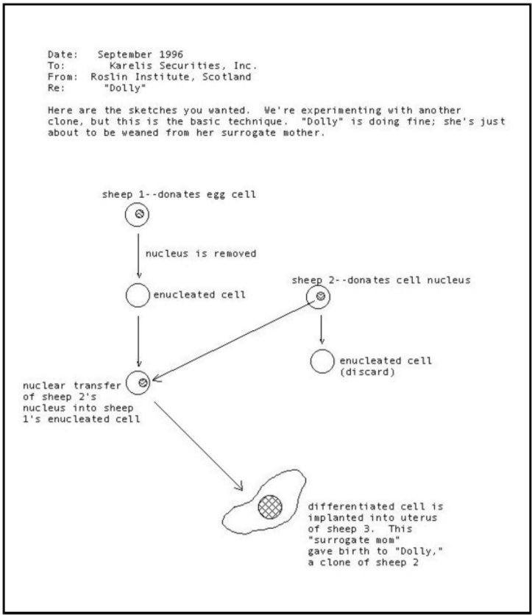
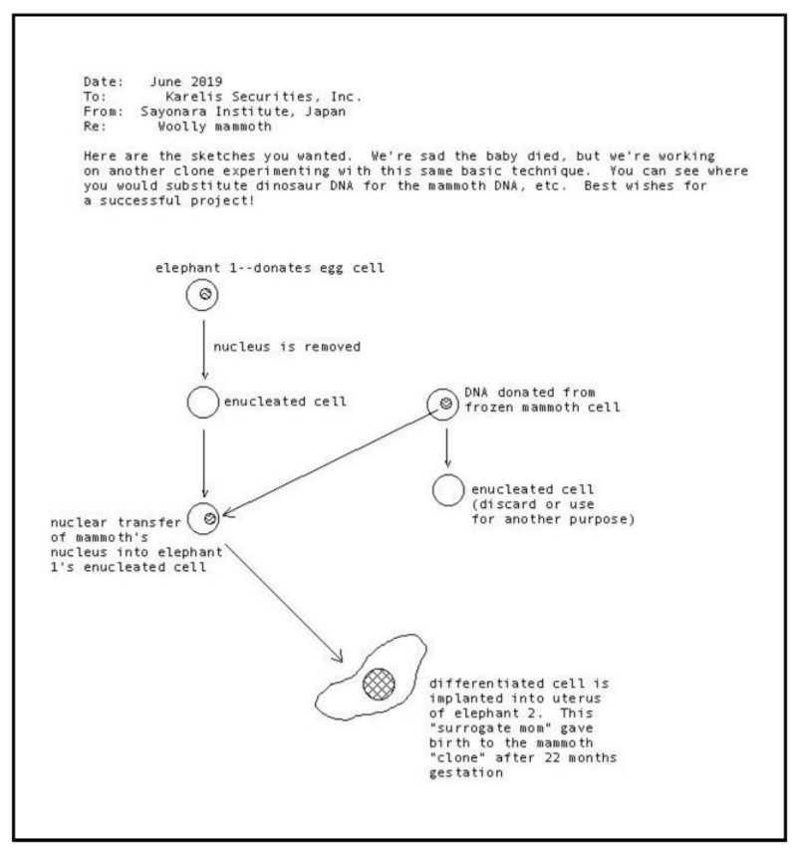

Official Memorandum

To: Esteemed Judges of the High Court
From: Supreme Court Justice Goodwin
Re: Dinosaur Cloning
I've been informed that you are going to be reviewing a case brought before your court on whether extinct forms of life (i.e., dinosaurs) should be cloned from ancient DNA. As this is the first such attempt at cloning dinosaurs, I would remind you that your decision carries great importance. I would also warn you that special interests are attempting to influence the case on both sides. It is your duty as judges to investigate the scientific and ethical aspects of the matter thoroughly so that you are sure of the evidence and arguments presented in court. I would urge you to review the various facts and theories of cloning, evolutionary principles, and dinosaurs. After you have completed your research, I recommend that you prepare questions to pose to both sides of the case before you. I have placed a large group of specialists on hand to advise you in your decision. Feel free to call on them to explain a fact or point out a discrepancy in the lower court's argument. I will be watching this case carefully, and expect YOU to reach the final decision. Good luck!
C. M. Goodwin,
Supreme Court Justice

Investor for cloning

To: Investor
From: Karelis Securities, Inc.
Re: Investments
I don't think I need to remind you how important this decision is for the future of this company. Karelis Securities has been a leader in cloning research since 1990 when we underwrote some of the initial research that led to the cloning of the sheep "Dolly" in the U.K. in 1996. Let's not forget that in 1997, The Lost World (sequel to the movie Jurassic Park) brought in a staggering $1 million per hour on opening week-end, and the T. rex dinosaur named "Sue" was auctioned for a record $8.4 million. I think it's clear that we cannot afford to miss this opportunity to create the ultimate theme park--the REAL Jurassic Park! Everyone loves dinosaurs so here's our chance to make a fortune. Who cares if the dinosaurs are artificially reproduced from hybridization with birds? This will be the ultimate fantasy. Instead of trying to build a time machine for travel into the past, we can bring the past to the present. We've just located a game park in Louisiana for sale--the initial investment needed to refurbish the park is incidental when compared to the millions of dollars it would take to locate, study, and prepare a new site. All of the infrastructure, buildings, roads, pens, and landscaping are intact. As for the dinosaurs and human safety, let's remind ourselves that humans are used to dealing with far more complex and dangerous life forms that evolved long after dinosaurs went extinct--we'll just put in a series of strategic fences to keep the dinosaurs in and humans out. I hear the paleontologists may be arguing against cloning by citing Gould's ideas about chance as an important process in evolution, using that as a scare tactic to conjure up visions of dinosaurs evolving into bizarre, truly frightening life forms in the future. Make sure you mention ideas about the dinosaur-bird link as a counter-attack and all the ways that dinosaurs can benefit humankind. I have compiled a short list of resources you might find useful. I don't care what you argue so long as you convince those judges to allow dinosaur cloning.
I'll be waiting for your report,
C. B. Karelis, CEO Karelis Securities

Investor against cloning

To: Investor
From: L&R Financing
Re: Dinosaur cloning
It would be an understatement to mention how much the judges' decision next week will affect our future--and yours. L&R Financing funded the building of DinoAdventures Theme Park in Wyoming several years ago. As you know, we've invested millions of dollars in the design of lifesize, robotic dinosaurs that will be guided by advanced computer technologies as they roam through a recreated Mesozoic landscape and engage in all sorts of real-live activities. Our engineers have been working with a team of geologists and biologists to make this the most compelling theme park of our age and one that can be duplicated at many other sites around the world. Should dinosaurs be brought back to life through cloning, we might as well close up shop now because robotic dinosaurs will never stand a chance against living, breathing dinosaurs in the public's eye. Your job is to convince the judges to veto dinosaur cloning. I have spoken to several specialists on evolution issues as well as animal rights activists and they all agree you could make a good case. You might try to argue that the planet will be unsafe and dangerous if dinosaurs are brought back to life--consider mentioning Phil Currie's latest discoveries or give them a first-hand look at one of our T. rex robotics! Point out that evolution cannot be controlled, not even by us. According to Gould, chance plays such an important role in evolution that using the Earth's past as a "future forecast" is foolish. Point out the enormous costs of producing, raising, and maintaining a captive breeding program of dinosaurs. I really don't care what you argue as long as you win this case. Dinosaurs must not be cloned! I've had my assistant type up a list of resources that might help you prepare your report.
Remember, we're counting on you!
Cassandra Moulton III
Managing Director, L&R Financing

paleontologist for cloning

Since you were a kid, you've been absolutely fascinated with dinosaurs. By age 5, you knew all the names of the saurischians and ornithischians and pointed out with glee every time someone mistakenly referred to Apatosaurus as Brontosaurus. (You must have seen the Jurassic Park movie a dozen times!). Your favorite dinosaur is Suchomimus, first described in 1998 by Paul Sereno based on his discoveries in northwest Africa. Since graduating from Fullam in 2003 (you got an A+ in Geo 115), you've become an expert on the detection and extraction of dinosaur DNA. The Ph.D. dissertation you completed a few years ago at a prestigious university on that very topic has placed you at the forefront of research on dinosaur cloning. Your research shows that there are more sites of potential DNA fossilized in dinosaur bones and blood proteins than most scientists realize, particularly bone beds like those in Montana where thousands of hadrosaurs were asphyxiated suddenly by ashfall during a volcanic eruption. The time is ripe for cloning dinosaurs-- imagine the research possibilities! Here would be the chance to view evolution first hand and to observe the locomotory styles, physiology, and reproductive behaviors of dinosaurs that scientists have debated for centuries. Who could turn down the opportunity to glimpse into the Earth's past and to undo the damage caused by the asteroid 66 million years ago? If you think about it, we (humans) aren't even supposed to be here--many scientists believe that if an asteroid hadn't wiped out the dinosaurs they'd still be the ruling forms of life in terrestrial environments. The best plan is for you to support dinosaur cloning and try to win a research grant to study the clones. Fame, fortune, and a pet dino might surely follow!

Paleontologist against cloning

Since you were a kid, you've been absolutely fascinated with dinosaurs. By age five, you knew all the names of the saurischians and ornithischians and pointed out with glee as often as possible that birds are really "feathered dinosaurs." (You must have read the Jurassic Park book a dozen times!). Your favorite dinosaur sites are in Argentina, where hundreds of sauropod eggs and some embryonic dinosaurs were discovered at the end of the last century. As much as you would love to see, hear, smell, and touch a living dinosaur, you realize that we are at a profound crossroads in the history of our planet if the judges allow cloning of extinct forms of life to proceed. Scientists are still debating if dinosaur DNA is fossilized intact or if it has survived in good enough shape to be used in cloning experiments. But it's only a matter of time before the technology will be developed that can replicate an entire genome from scraps of fossil DNA. It's no longer a question of technology but rather a question of what's right. The Mesozoic world of the dinosaurs no longer exists--many of the dinosaurs' cohort species, including multituberculate mammals, archaic crocodiles, Archaeopteryx, pterosaurs, as well as early species of cycads and even primitive angiosperms, went extinct millions of years ago. Even Pangea and the climatic conditions that prevailed on Earth during the "Age of Dinosaurs" no longer exist! It would be unfair to the dinosaurs to bring them back into a world that no longer has a place for them. Their time has come and gone. You've joined with a prestigious group of fellow scientists to urge the judges to ban dinosaur cloning.
Robin Forster, Columbia Ph.D., vertebrate paleontologist
and signatures of other Scientists Against Cloning (SAC):
Xenia Krasnikova, Moscow Ph.D., conservation biologist
Jim Starr, Harvard Ph.D., pathologist
R.J. Browne, Stanford Ph.D., paleobotanist
+100 other names

Geneticist for cloning

New cloning techniques have made what was once believed impossible now possible. These new technologies allow for the extraction and purification of minute amounts of fossilized DNA, which is then activated, amplified, and replicated before being used for in vitro fertilization. Just last year a Japanese scientist cloned the first living mammoth by extracting the nucleus from the cell of a frozen (Pleistocene) mammoth, injecting it into an elephant's enucleated cell, and then implanting the viable embryo into an Asian elephant. Even though the baby mammoth only lived for a few days and was the clone of an animal that died out only a few thousand years ago, this represents a real step forward in cloning dinosaurs. What a fantastic opportunity—to be in on the ground level of a major scientific discovery that builds on the technologies already benefitting many humans worldwide, especially infertile couples who want to have children. There would be little to fear in bringing dinosaurs back from extinction--no "monsters" would evolve because genetic manipulations would carefully limit evolution. Also in your testimony next week it will be important to point out that cloning dinosaurs could help to develop new drugs to fight human diseases. The technological advances stemming from research on cloned dinosaurs could also potentially improve food production around the world with genetically engineered plants that could save the thousands of people who die each year from starvation. One of your colleagues has also proposed producing genetically engineered plants as benign alternatives to our dwindling fossil fuel resources. You plan to urge the judges to approve the cloning of dinosaurs because of the many potential benefits to society.

Geneticist against cloning

New advances in genetic engineering are on the cusp of bringing extinct species back to life, but nobody explains how difficult, risky, and expensive this is--especially given the high percentage of failed attempts before a successful live birth is achieved. For example, some molecular biologists estimate that one out of every 1000 attempts will result in a fully formed, live dinosaur hatchling, and then there's the challenge of preventing high rates of infant mortality. Problems with verifying it's really dinosaur DNA and changes in DNA over the past 66 million years can't be ignored, either--you're concerned about the possibility of creating a "Frankenstein"-like hybrid that will be out of control and beyond the limits of nature and natural selection in the Darwinian sense. It still isn't clear how a dinosaur clone would be created--for example, would the clone be a bird-dinosaur or crocodile-dinosaur hybrid? Or would the "clone" be just a chicken walking around with some dinosaur DNA as part of its genetic make-up? After considerable expense, it's still unknown if the hybrid would be fertile or sterile and which dinosaur would be resurrected--T. rex perhaps? Which dinosaur-related species would provide the donor eggs, and which species would be the surrogate mothers? Now is the time for scientists and society to acknowledge that it is justifiable to use new techniques and scientific advances to solve today's problems but wrong to add new problems. You plan to explain to the court that dinosaur cloning is an improper use of scientific technology that shows little regard for the animals being brought back into a world unprepared to receive them. Is it really desirable to clone dinosaurs with the express purpose of making them into living drug factories for pharmaceutical companies? If dinosaurs are cloned, what's next--cloned trilobites? Cloned ichthyosaurs? You even heard mention of a report that someone wants to search for frozen sperm in the mummified Ice Man, Ötzi, and clone him 5000 years after his death in the Italian Alps! It was a mistake to attempt the cloning of the mammoth last year, and cloning even older forms of life would only create more problems. You hope to convince the judges that we have absolutely no right to play God!

Ethicist for cloning

What a fantastic opportunity!--to be in on the ground level of a major scientific discovery that builds on the technologies already benefiting many humans worldwide, especially infertile couples who want to have children. As the geneticists have pointed out, there would be little to fear in bringing dinosaurs back from extinction--no "monsters" would evolve because genetic manipulations would carefully limit evolution. In your testimony next week, it will be important to research all of the various ways that cloning dinosaurs could be beneficial to humans. Could the cloned dinos help to develop new drugs to fight human diseases or be used for organ transplants, tissue regeneration in burn victims, or bone grafts? Could technological advances stemming from research on cloned dinosaurs also potentially improve food production around the world with genetically engineered plants that could save the thousands of people who die each year from starvation? Would advances in cloning research enable us to produce genetically engineered plants as benign alternatives to our dwindling fossil fuel resources? Forget the arguments that this goes against nature--the fact of the matter is that in reality we already select which natural processes to manipulate for the benefit of humankind. You'll provide specific examples to the judges so that they fully appreciate the extent to which humans have been manipulating nature since the advent of agriculture 10,000 years ago and more recently with the accelerated development of bioengineered plants, medicines, and selectively bred livestock. It's important to acknowledge that scientific and technological breakthroughs aren't achieved without some risks. If cloning dinosaurs could yield tremendous insights into how and why certain manipulations of cellular material are successful, as an ethicist you need to thoughtfully assess if the benefits outweigh the risks. The judges may also wish to have clear assurances that the dinosaurs will be managed under carefully monitored, humane conditions. It's time to quit demonizing science--you plan to urge the judges to approve the cloning of dinosaurs because of the many potential benefits to society.

Ethicist against cloning

You are gravely concerned that we are at a profound crossroads in the history of our planet if the judges allow cloning of extinct forms of life to proceed. Your geneticist colleagues assure you that it's only a matter of time before the technology will be developed that can replicate an entire genome from scraps of fossil DNA. It's no longer a question of technology but rather a question of what's right. This will be your opportunity to ask some probing questions--should scientists and society acknowledge that it is justifiable to use new techniques and scientific advances to solve today's problems but wrong to introduce new hazards through uncontrolled ecological experiments? You'll need to explain to the court why dinosaur cloning is an improper use of scientific technology, which from an ethical standpoint shows little regard for the animals being brought back into the modern world. Is it relevant that the Mesozoic world of the dinosaurs no longer exists--for that reason alone is it unfair to resurrect the dinosaurs? Has their time really come and gone? Is it really desirable to clone dinosaurs with the express purpose of making them into living drug factories for pharmaceutical companies? If dinosaurs are cloned, what's next--cloned trilobites? Cloned ichthyosaurs? You even heard mention of a report that someone wants to search for frozen sperm in the mummified Ice Man, Ötzi, and clone him 5000 years after his death in the Italian Alps! You'll have to convince the judges that it was a mistake to attempt the cloning of the mammoth last year and that cloning even older forms of life would only create more problems. You'll need to investigate if a rush for profits and slow action on the part of governments to establish regulations for safety oversight will promote unethical behaviors, including mistreatment of these complex, intelligent, social animals and possible environmental damage caused by doctored genes spreading out of control. You've joined with a prestigious group of fellow scientists to urge the judges to ban dinosaur cloning. From an ethical standpoint there's no good basis or rational reason for cloning dinosaurs--we have absolutely no right to play God!
Robin Forster, Columbia PhD, vertebrate paleontologist
and signatures of other Scientists Against Cloning (SAC): Xenia Krasnikova, Moscow PhD, conservation biologist Jim Starr, Harvard PhD, pathologist R.J. Browne, Stanford PhD, paleobotanist +100 other names

Veterinarian for cloning

As the chief veterinarian at game parks in western North America, Africa, and Australia, you oversaw the care and feeding of reptiles, including the Komodo "dragon," as well as large herds of mammals in nature preserves in Kenya. The chance to manage the first group of cloned dinosaurs is a job too exciting to pass up. You plan to tell the judges that years of experience in animal husbandry in wild and domesticated stock lead you to believe that the management of dinosaurs is not an insurmountable problem. You'll note that during the Mesozoic, dinosaurs had co-evolved with a diversity of plants, including early angiosperms. Dinosaurs demonstrated over millions of years a considerable adaptability to new food sources throughout the Mesozoic. As ecologic generalists, you predict that they will adjust well to the wide assortment of grains and grasses that modern mammals depend on to fuel their active lives. You've already been involved in an experimental program in Tanzania where vaccinations of lions and cheetahs successfully boosted their immune systems and prevented the further spread of deadly viruses, which have culled many populations of African felids. Similar techniques could be applied to dinosaurs so that their Mesozoic immune systems would be able to tolerate Cenozoic diseases. Daily maintenance and care of dinosaurs would ensure their survival under carefully monitored conditions by well-trained staff. Furthermore, as a pathologist interested in the origins of diseases that still plague humankind, you see a real benefit in being able to investigate the factors associated with arthritis and syphilis, diseases that also affected dinosaurs. Finally, you will urge the judges to allow dinosaur cloning by pointing out that cloned dinosaurs could also benefit humans by serving as a source for bone grafts and possibly even organ and tissue transplants.

Veterinarian against cloning

As an experienced pathologist who specializes in large-bodied animals, you have considerable discomfort about the monumental efforts, expense, and uncertainty involved in the care, maintenance, and management of cloned dinosaurs. Anyone who knows anything about modern ecosystems appreciates that boundaries are diffuse and that ecological "osmosis" takes place across invisible or non-existent borders. In other words, captive animals are not completely protected from outside influences and vice versa. Dinosaurs would probably need to be fed with genetically altered plants from which the deadliest toxins have been removed. Angiosperms have experienced enormous evolution in the last 60 million years, and dinosaurs would not have adaptations to aid in the digestion of plants they never encountered in the Mesozoic. Didn't somebody once propose that dinosaurs became extinct after suffering severe digestive disorders shortly after the evolution of the first angiosperms? Modern viruses could wreak havoc on the immune systems of the dinosaurs as well; even new experiments to boost the immune systems of endangered species have not been able to save all members afflicted with a deadly virus. You're also worried that Mesozoic diseases that died out with the dinosaurs could be reintroduced into the modern world. Cloning dinosaurs could possibly recreate a dangerous pathogen and contaminate other animals in nearby habitats. Mosquitoes and other insects are known vectors that transfer diseases among species. You're fearful that many birds and crocodiles, already threatened with extinction in many parts of the world, might suffer even greater losses as evolutionary relatives of the dinosaurs that are susceptible to the same diseases. Finally, you plan to end your testimony with an image that the judges will be unable to forget of a five-ton Triceratops with meter-long horns charging towards a bus filled with tourists... Dinosaur cloning is better left alone!

Citizen for CLoning

What's the big deal? Nature's already full of clones--your doctor once told you that you and your twin brother are a form of cloning and there's nothing particularly bizarre or frightening about the two of you! Doesn't it come down to the Nature vs. Nurture debate--that individuals are shaped both by their genetic heritage and by the environment? You don't really understand all the stuff about how a clone is actually developed, but if the scientists are telling us that dinosaurs can be genetically engineered with careful manipulations of their DNA and that they will exist under controlled environmental conditions, what's the big scare? What could be cooler than visiting an outdoor theme park and watching dinosaurs do their thing. They've got to be the biggest, baddest beasts that ever walked the Earth. Science fiction just doesn't do it anymore; this will be the REAL thing. Everyone seems to be worried about science unleashing uncontrollable, violent forces into society, but humans are used to dealing with all kinds of violence, like inner-city gangs, earthquakes, killer viruses, etc. Also haven't the newspapers been reporting all the benefits we derive from genetic engineering, like medicines, better foods, organ transplant research, etc.? Scientific research on cloning isn't necessarily a bad thing, we just have to be careful what kind of cloning is done. Dinosaurs obviously weren't the brightest critters, otherwise they wouldn't have gone extinct as evolutionary failures, right? So here's a second chance for them to reinhabit planet Earth while providing some enjoyment and benefit to humankind. Sounds like a pretty fair deal!

Citizen against Cloning

What's the big deal? Who are we trying to kid? Here we are talking about bringing back the largest animals that ever walked the planet, including T. rex. Doesn't planet Earth already have enough problems—human overpopulation, famine, disease, poverty, pollution, species extinctions, you name it. We can't even feed all the starving people in the world, never mind a bunch of cloned dinosaurs. What kind of world will we be leaving our children if in addition to everything else they have to deal with extinct forms of life brought back from the past? Didn't Newsweek say that 60 million years separates the dinosaur age from the human age? Think of all the changes that must have taken place in that amount of time. It doesn't seem like a good idea to fool around with nature on that scale. So they tell us the dinosaurs would be caged in zoos and big animal parks. What about the reports from Florida last year of lions and tigers escaping from that zoo? It's only a matter of time before some smart dinosaur finds a way to sneak out of the zoo, and then imagine what would happen. There must be some mad scientists somewhere out to control the world. You plan to say loudly and clearly in court next week that under no circumstances should dinosaur cloning be allowed!

Information Resources
Magazine and Journal Articles:
"Cloning the Woolly Mammoth." Richard Stone. Discover, vol. 20, April
1999, p. 56-63.
"Ancient DNA." Svante Pääbo. Scientific American, vol. 269, November
1993, p. 86-92.
"Ancient DNA." George Poinar, Jr. American Scientist, vol. 87, September-
October 1999, p. 446-457.
"Dino DNA: The Hunt and the Hype." Virginia Morell. Science, vol. 261, 9
July 1993, p. 160-162.
“The Use of Ancient DNA in Paleontological Studies." Lori M. and Zvi
Kelman. Journal of Vertebrate Paleontology, vol. 19, March 1999, p. 8-20.
"The Real Jurassic Park." Mary Schweitzer and Tracy Staedter. Earth, vol. 6,
June 1997, p. 54-57.
"Will the Dinosaurs Rise Again?" Mary H. Schweitzer and Raul J. Cano. In
DinoFest (edited by Gary D. Rosenberg and Donald L. Wolberg), 1994, p.
309-326.
"DNA Sequence from Cretaceous Period Bone Fragments." Scott R.
Woodward et al. Science, vol. 266, 18 November 1994, p. 1229-1232.
“Detecting Dinosaur DNA." [various authors.] Science, vol. 268, 26 May
1995, p. 1191-1194.
"Dino Hunter." Josh Fischman. Discover, vol 19, May 1999, p. 72-78.
"Is Science Dangerous?" Lewis Wolpert. Nature, vol. 398, 25 March 1999, p.
281-282.
Cloning E-Folder:
Memo dated September 1996
Memo dated June 2019
Internet Sites:
Recreating Dinosaurs: Fact or Fiction?
http://www.nhm.ac.uk/about-us/page-not-found.html
http://www.gplatt.demon.co.uk/amberdna.htm
http://unmuseum.mus.pa.us/dnadino.htm
https://www.scientificamerican.com/askexpert/biology/biology1.html
https://www.newscientist.com/nsplus/insight/rexfiles/backfrom
http://www.dinosauria.com/
http://dinosaurs.eb.com/dinosaurs/index2.html
Cloning Info
https://www.scientificamerican.com/explorations/030397clone/030397beards.html
https://www.scientificamerican.com/1998/1298issue/1298wilmut.html
https://www.newscientist.com/nsplus/insight/clone/clonelinks
http://library.thinkquest.org/24355/data/debatenav.html
http://powayusd.sdcoe.k12.ca.us/dolly/resources.htm
Books:
The Science of Jurassic Park and The Lost World or, How to Build a
Dinosaur. Rob DeSalle and David Lindley. 1997. BasicBooks.
The Quest for Life in Amber. George O. Poinar. 1994. Addison Wesley
Longman, Inc.
The Second Creation: Dolly and the Age of Biological Control. Ian
Wilmut, Keith Campbell, and Colin Tudge. 2000. Farrar Straus &
Giroux.
Clone: The Road to Dolly and the Path Ahead. Gina Kolata. 1998. W.
Morrow & Co.
Remaking Eden: Cloning and Beyond in a Brave New World. Lee Silver.
1997. Avon Books.
Biology. N.A. Campbell. 1987. Benjamin-Cummings Publishing Co.

